THE SWEDENBORG LETTER PATENT
AND GRANT OF ARMS

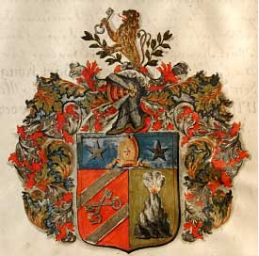

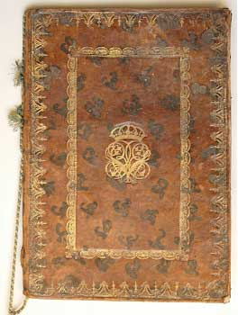

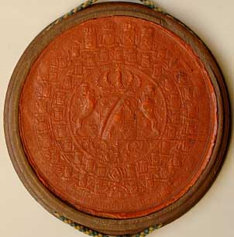

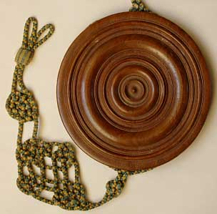
Sidan. 3
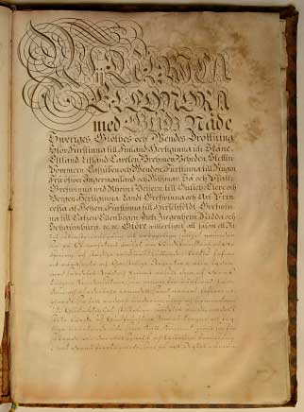

We, Ulrika Eleanora
By the Grace of God
Queen of Sweden, Gothia and Wende,
High Princess of Finland, Duchess of Skåne,
Estonia, Latvia, Karelia, Bremen, Mehrden, Stettin-
Pommern, Kazuben and Wenden, Princess of Rugen,
Mistress of Ingermanland and Wizmar; so also Pfaltz
Countess on the Rhein in Bavaria, Duchess of Gulich, Kleve and
Bergen; Landt Countess and Hereditary Princess
of Heszen, Princess of Hirschfeldt, Countess
of Katzen Ellenbogen, Dietz, Siegenheim Nidda and
Schaumburg etc., maketh known that insofar as the surest

welfare and constant felicity of a kingdom is founded
upon the tender care of the true practice and steadfast preservation of Piety by Authority; therefore have
also righteous and Christian rulers in all times
by particular grace and favour succoured those
faithful subjects of the aforesaid rulers whosoever by the acquisition of learning
and blameless conduct and besides honourable mode of life
have made themselves proficient in the education of others and the encouragement
of Godliness, particularly so because they through
the faithful and unceasing labours of such learned men
in their calling have received assurance
of those blessings and good fortune
in all their affairs such as must without fail follow upon

Sidan 4
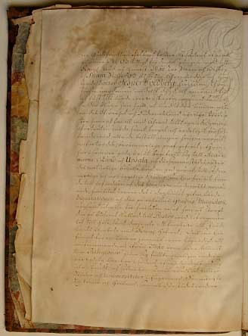

the general Piety of a Kingdom: In this respect
we remember in this instance with all
Royal Grace and favour our loyal subject and Bishop
of the Diocese of Skara the honourable and learned
Doctor Jesper Svedberg, who from
his earliest youth with virtue and both diligence
and love for true learning, hath let shine forth exceedingly
the eagerness he hath felt to be able in time to offer
useful service to Authority and to the Fatherland,
of which he hath with the advance of years through
unceasing effort and loyal and spiritual application
to all the tasks laid upon him, given praiseworthy proof; he
hath with the same noble aim attended the Academies
of Lund and Uppsala, and in those places according
to his natural inclination, laid a useful foundation for such
useful and enriching studies as he hath found
to advance the achievement of these determined aims,
which is distinctly shown by the two learned
disputations which there saw the light of day, and the gradus Magisterii
thereby awarded, for which reason he soon
thereafter was called to the Pastorate of the Cavalry Guards Regiment,
and likewise to perform the duties of Minister
at the Royal Court. However as he judged it
also to be essential for a Teacher
fully to inform himself about foreign and from our pure doctrine
distinct religions, he hath therefore to this end travelled
abroad, and after not only visiting numerous
cities and universities in England, France,
Germany and Holland, but also there

Sidan 5
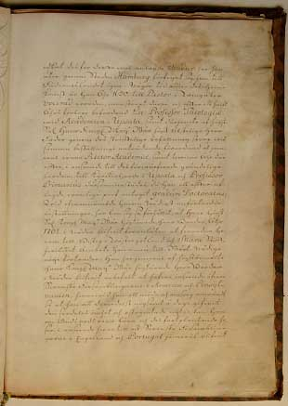

pursuing his for this purpose well-found studies, he hath
returned through the city of Hamburg
to the Fatherland. Some time after his return
he hath in the year 1690 been called to the Pastorate in Wingåker,
but soon thereafter and after the course of half
a year hath been promoted to Professor of Theology
at the Academy in Uppsala, and likewise by his most
Blessed Royal Majesty our greatly beloved
Father by His Royal command immediately upon entering
said position hath been required
also to be Rector Academiae and also two years
thereafter, in recognition of his profound
learning, to be Vicar in Uppsala and Professor
Primarius in that place, when he also after
passing the usual examinations attained the degree Doctoratus;
in the aforesaid offices which to him were graciously entrusted,
he hath so conducted himself that his most
Blessed Majesty our highly honoured Brother in the year
1702 hath in his grace thought fit to appoint him
Bishop of West Götaland and the diocese of Skara,
which office he yet occupies to Our gracious
satisfaction. He hath likewise by His same aforementioned
Royal Majesty Our most honoured Brother
graciously been set to superintend
the Swedish congregations in America and Pennsylvania,
wherein he hath used all pains and care
so that he even by these means hath very well revealed
that special affection and generous zeal he
owneth for the true teachings of God and their propagation,
in recognition of which also the Swedish congregations
in England and Portugal have likewise
Sidan 6
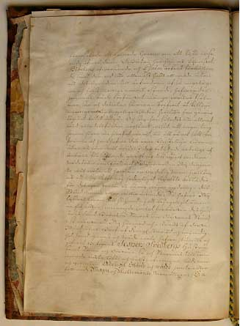

been given cause to entreat him to have supervision
of them. What is more he hath also lent his services
to the revision of the Bible and the improvement of the Hymnbook,
and therein not only expended great effort but
also his own property to forward such important
and highly valuable works, this being done unasked. He hath
also composed many beautiful hymns
and even written many
useful and edifying books, which he hath
had printed. And thus insofar as he hath
on all occasions not only clearly shown that nothing
hath been closer to his heart than in every way to advance
and preserve the true Christian teaching,
but likewise by his attested spiritual
and honourable life made himself well deserving of some further
act of grace; however whereas we further
know well that although as a spiritual man, who
also holdeth an office in itself honourable enough,
he is not served by, nor can, nor will
for his own person’s sake endow himself with
any change in estate; so have We
none the less for his gratification and for a commemoration
pleasing to his descendants desired to raise the honourable Estate
of his Wife and Children, Sons as well as daughters,
in such measure that We herewith and by the power of this
Our Letter Patent by Royal Power and authority,
and grace and favour, have granted and
given to the Wife of Bishop Jesper Svedberg,
and his Sons and daughters, and also of those Sons the future legitimate
issue and descendants, both male
and female, noble estate and degree, together with
the here following Arms and Escutcheon, namely:
Sidan 7
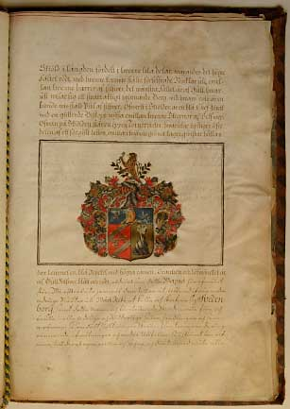

Per pale Gules and Or on the dexter side two Keys in
saltire between as many Bendlets sinister Argent on the sinister
side a rocky Mount enflamed proper charged in base with an
Arrow bendwise point upwards Argent on a Chief Azure a
Mitre Or between two Mullets Argent:
Crest
On a Wreath Argent Gules Or and Azure Between two Sprigs of Laurel a demi Lion queue fourchy Or holding in the dexter paw a Key in bend sinister Azure
Mantled Gules and Azure lined Argent and Or,
just as these Arms stand here depicted.
Likewise do We grant to them as a distinction from other
noble families in Our realm to call themselves and to write themselves Swedenborg,
and to bear this name and the arms above depicted
in all noble and Chivalrous affairs, deeds and meetings:
such as battles, skirmishes, tournaments, chivalrous
sports, portraiture and other occasions, whether in jest or
in earnest, for their own will, use and pleasure, and thereto also enjoy all
Sidan 8
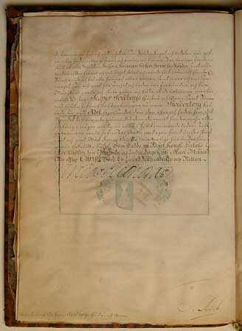

the advantages, freedoms and rights which are afforded Knighthood and nobility,
or hereafter come to be so afforded and granted. For this reason we require
of all Powers, Emperors, Kings, Princes, Gentles, Freemen and all others
according to their position, estate and worth, with diligence, friendship and favour;
So also We herewith request and require all men in general and each and every one
in particular whosoever is bound to us in loyalty and obedience, and for
Our sake would and should act and permit, that they recognise
the Wife and Children of the aforesaid Bishop Jesper Svedberg, and
of the Sons the legitimate issue and descendants, now called Swedenborg,
as true Nobility, showing them all esteem and honour as becomes
that estate, raising against this no hindrance, injury or
detriment in any degree now or in times to come. As
further surety We have with Our own hand signed this Letter
and with Our Royal Seal hereunder attached let
certify it. At Our Royal Palace
in Stockholm the three and twentieth day of the Month of May
in the Year of Our Lord One Thousand, Seven Hundred, and Nineteen.

Ulrika Eleanora.

